Radio Access Network (RAN)

📡 What Is a Radio Access Network (RAN)?
# Source: AI Source: Provided by: [Data Path: Persons Table -> ID Column: 1, Name_En Column: Motasem Essam] -> From: [ChatGPT] on [1/23/2026]
A Radio Access Network (RAN) is the part of a mobile communication system that connects your device (phone, tablet, modem) to the core network using radio signals. It includes the cell towers, antennas, and base stations that transmit and receive wireless signals to and from your device.
🛰️ RAN is like the “front line” of a mobile network — it’s what your phone talks to first when making a call or using data.

🧩 Components of a RAN:
# Source: AI Source: Provided by: [Data Path: Persons Table -> ID Column: 1, Name_En Column: Motasem Essam] -> From: [ChatGPT] on [1/23/2026]
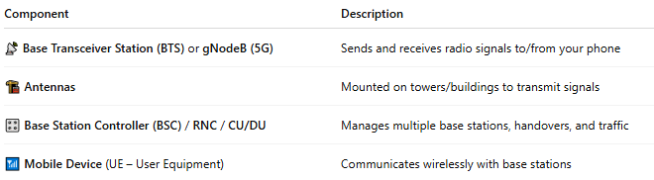

Component | Description
📡 Base Transceiver Station (BTS) or gNodeB (5G) | Sends and receives radio signals to/from your phone
🏗️ Antennas | Mounted on towers/buildings to transmit signals
🎛️ Base Station Controller (BSC) / RNC / CU/DU | Manages multiple base stations, handovers, and traffic
📶 Mobile Device (UE – User Equipment) | Communicates wirelessly with base stations

📶 RAN by Generation:
# Source: AI Source: Provided by: [Data Path: Persons Table -> ID Column: 1, Name_En Column: Motasem Essam] -> From: [ChatGPT] on [1/23/2026]
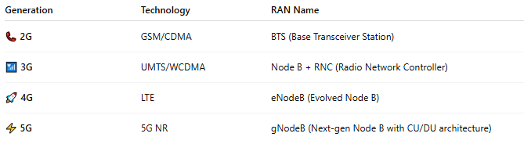

Generation | Technology | RAN Name
📞 2G | GSM/CDMA | BTS (Base Transceiver Station)
📶 3G | UMTS/WCDMA | Node B + RNC (Radio Network Controller)
🚀 4G | LTE | eNodeB (Evolved Node B)
⚡ 5G | 5G NR | gNodeB (Next-gen Node B with CU/DU architecture)

🔁 How RAN Works (Simplified):
# Source: AI Source: Provided by: [Data Path: Persons Table -> ID Column: 1, Name_En Column: Motasem Essam] -> From: [ChatGPT] on [1/23/2026]
- 📱 Your phone powers on and searches for a signal.
- 📡 It connects to the nearest base station (BTS/gNodeB).
- 🔄 The RAN handles radio communication (calls, data, handovers).
- 🌐 It forwards the signal to the core network for internet, calls, and services.

🧠 RAN Responsibilities:
# Source: AI Source: Provided by: [Data Path: Persons Table -> ID Column: 1, Name_En Column: Motasem Essam] -> From: [ChatGPT] on [1/23/2026]
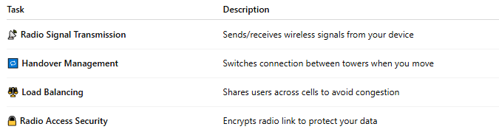

Task | Description
📡 Radio Signal Transmission | Sends/receives wireless signals from your device
🔁 Handover Management | Switches connection between towers when you move
⚖️ Load Balancing | Shares users across cells to avoid congestion
🔒 Radio Access Security | Encrypts radio link to protect your data

🆚 RAN vs Core Network:
# Source: AI Source: Provided by: [Data Path: Persons Table -> ID Column: 1, Name_En Column: Motasem Essam] -> From: [ChatGPT] on [1/23/2026]
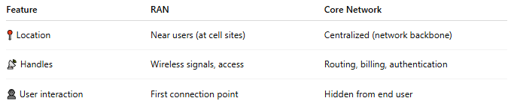

Feature | RAN | Core Network
📍 Location | Near users (at cell sites) | Centralized (network backbone)
📡 Handles | Wireless signals, access | Routing, billing, authentication
👤 User interaction | First connection point | Hidden from end user

🏗️ Variants of RAN:
# Source: AI Source: Provided by: [Data Path: Persons Table -> ID Column: 1, Name_En Column: Motasem Essam] -> From: [ChatGPT] on [1/23/2026]
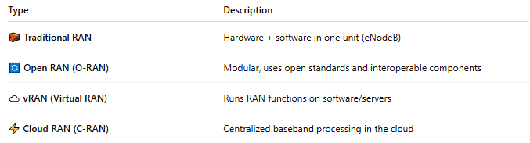

Type | Description
🧱 Traditional RAN | Hardware + software in one unit (eNodeB)
🔄 Open RAN (O-RAN) | Modular, uses open standards and interoperable components
☁️ vRAN (Virtual RAN) | Runs RAN functions on software/servers
⚡ Cloud RAN (C-RAN) | Centralized baseband processing in the cloud

📖 Summary:
# Source: AI Source: Provided by: [Data Path: Persons Table -> ID Column: 1, Name_En Column: Motasem Essam] -> From: [ChatGPT] on [1/23/2026]
The Radio Access Network (RAN) is the wireless bridge between your phone and the mobile operator’s core systems. It includes the towers and base stations that transmit radio signals, manage user connections, and handle mobility (like handovers while moving).

